**MANDATOTARY EXERCISE:’**

**Exercise 1: Control Structures**

**Scenario 1:**

DECLARE

CURSOR cur_eligible_loans IS

SELECT l.loanID, l.interestRate

FROM loans l

JOIN customers c ON c.customerID = l.customerID

WHERE TRUNC(MONTHS_BETWEEN(SYSDATE, c.DOB) / 12) > 60;

BEGIN

FOR rec IN cur_eligible_loans LOOP

UPDATE loans

SET interestRate = rec.interestRate * 0.99 -- 1 % drop

WHERE loanID = rec.loanID;

END LOOP;

COMMIT;

EXCEPTION

WHEN OTHERS THEN

ROLLBACK;

RAISE;

END;

/

**OUTPUT:** 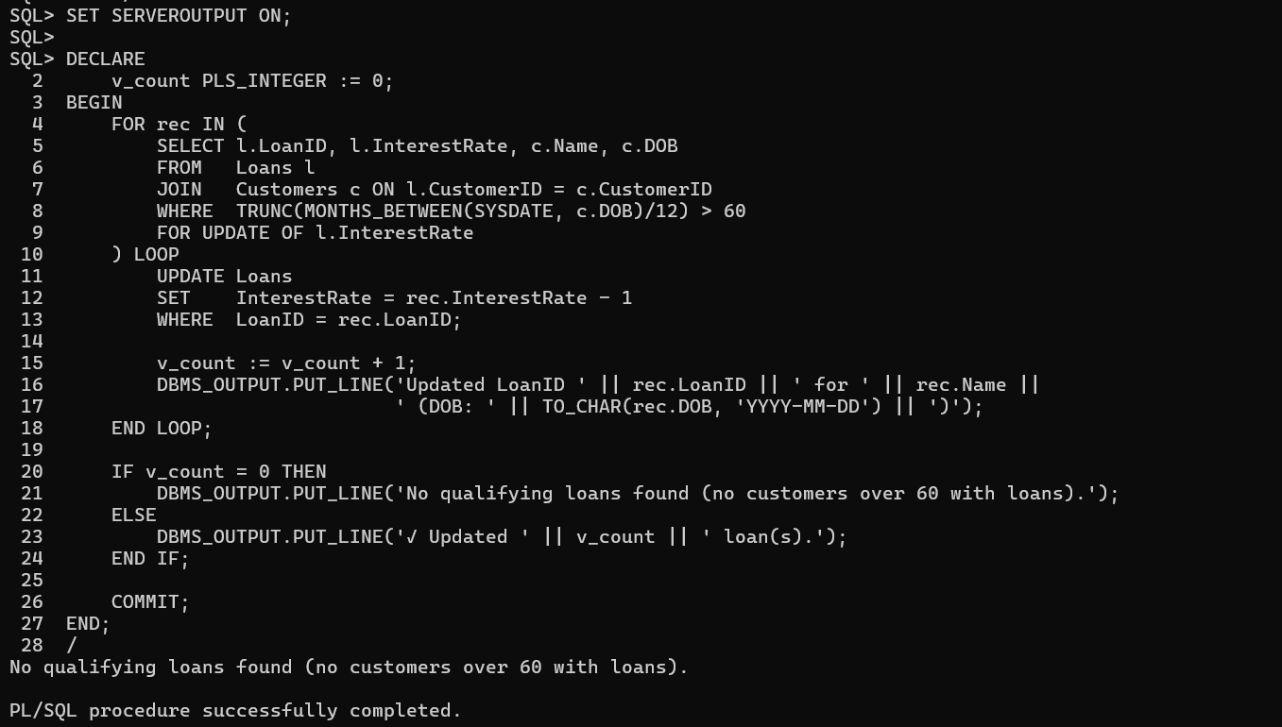

**Scenario 2:**

DECLARE

CURSOR cust_cursor IS

SELECT CustomerID, Balance FROM Customers;

BEGIN

FOR cust_rec IN cust_cursor LOOP

IF cust_rec.Balance > 10000 THEN

UPDATE Customers

SET IsVIP = 'TRUE'

WHERE CustomerID = cust_rec.CustomerID;

ELSE

UPDATE Customers

SET IsVIP = 'FALSE'

WHERE CustomerID = cust_rec.CustomerID;

END IF;

END LOOP;

OMMIT;

EXCEPTION

WHEN OTHERS THEN

ROLLBACK;

RAISE;

END;

/

**OUTPUT:**

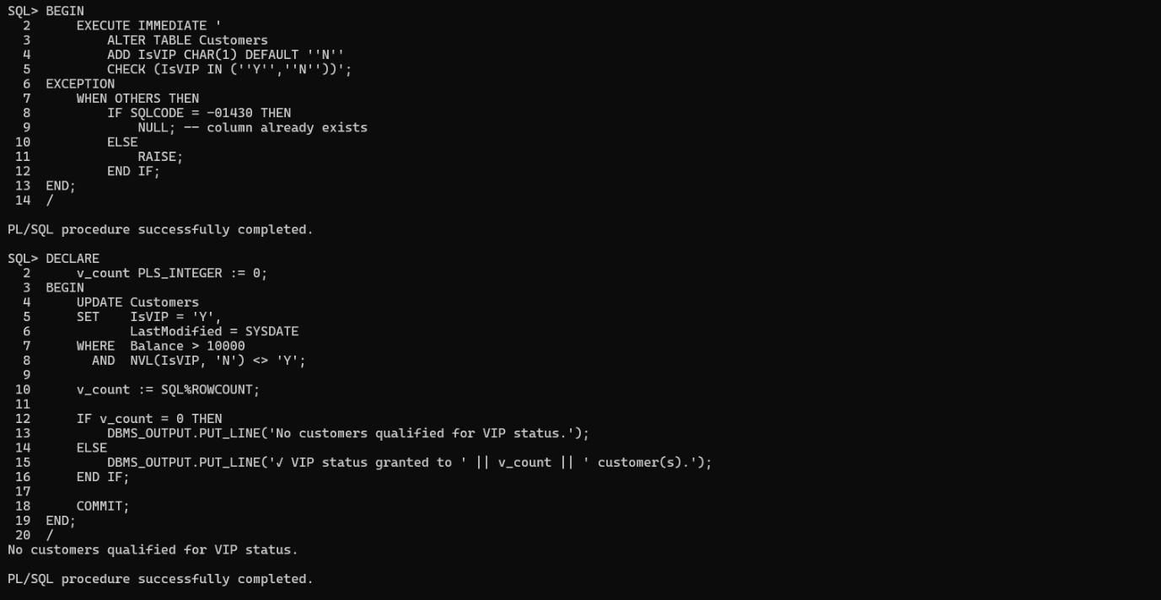

**Scenario 3:**

**SET SERVEROUTPUT ON**

**DECLARE**

**CURSOR cur_due_loans IS**

**SELECT l.loanID,**

**l.customerID,**

**l.loanAmount,**

**l.endDate,**

**c.name**

**FROM loans l**

**JOIN customers c ON c.customerID = l.customerID**

**WHERE l.endDate BETWEEN TRUNC(SYSDATE)**

**AND TRUNC(SYSDATE) + 30;**

**v_count NUMBER := 0;**

**BEGIN**

**FOR rec IN cur_due_loans LOOP**

**DBMS_OUTPUT.PUT_LINE (**

**'REMINDER: Dear ' || rec.name ||**

**' (Customer ' || rec.customerID || '), your loan #' || rec.loanID ||**

**' of $' || TO_CHAR(rec.loanAmount, 'FM999G999G999') ||**

**' is due on ' || TO_CHAR(rec.endDate, 'YYYY-MM-DD') ||**

**'. Please arrange payment or contact the bank.'**

**);**

**v_count := v_count + 1;**

**END LOOP;**

**IF v_count = 0 THEN**

**DBMS_OUTPUT.PUT_LINE('No loans are due within the next 30 days.');**

**END IF;**

**END;**

**/**

**OUTPUT:**

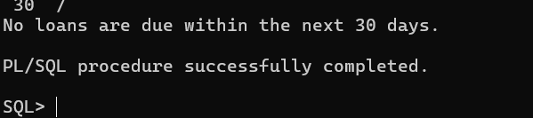

**Exercise 3: Stored Procedures**

**Scenario 1**

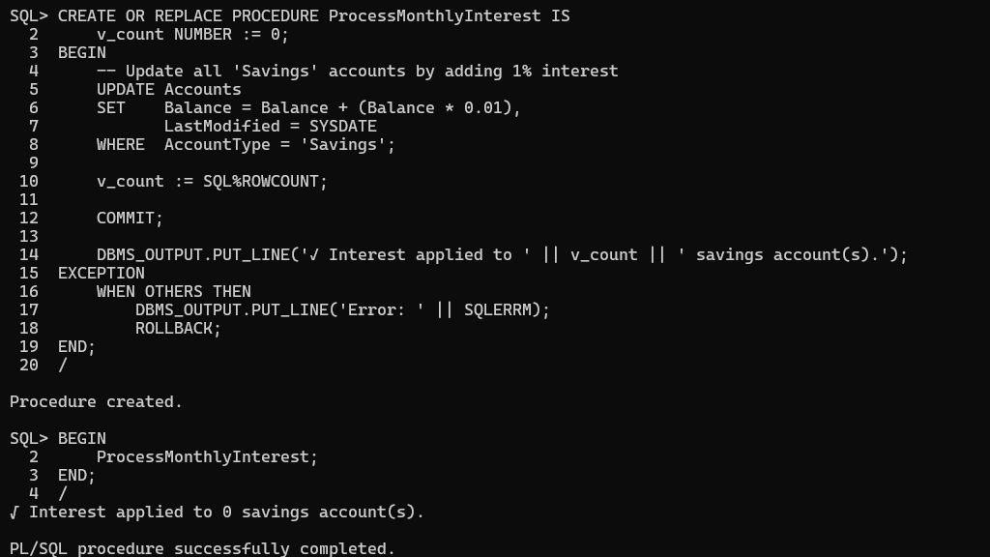

**Scenario 2:**

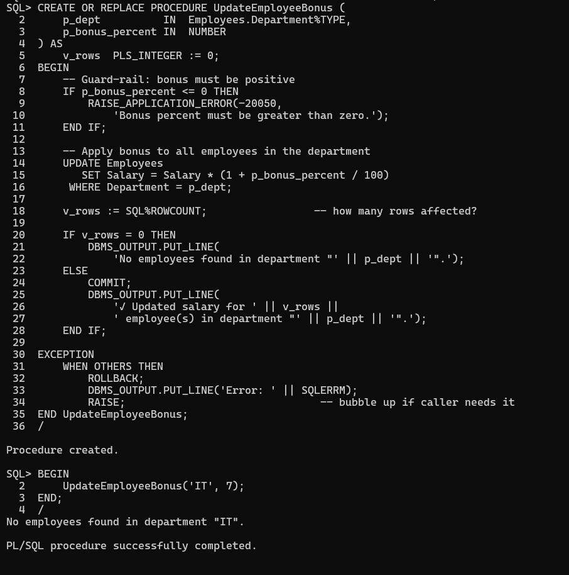

**Scenario 3:**

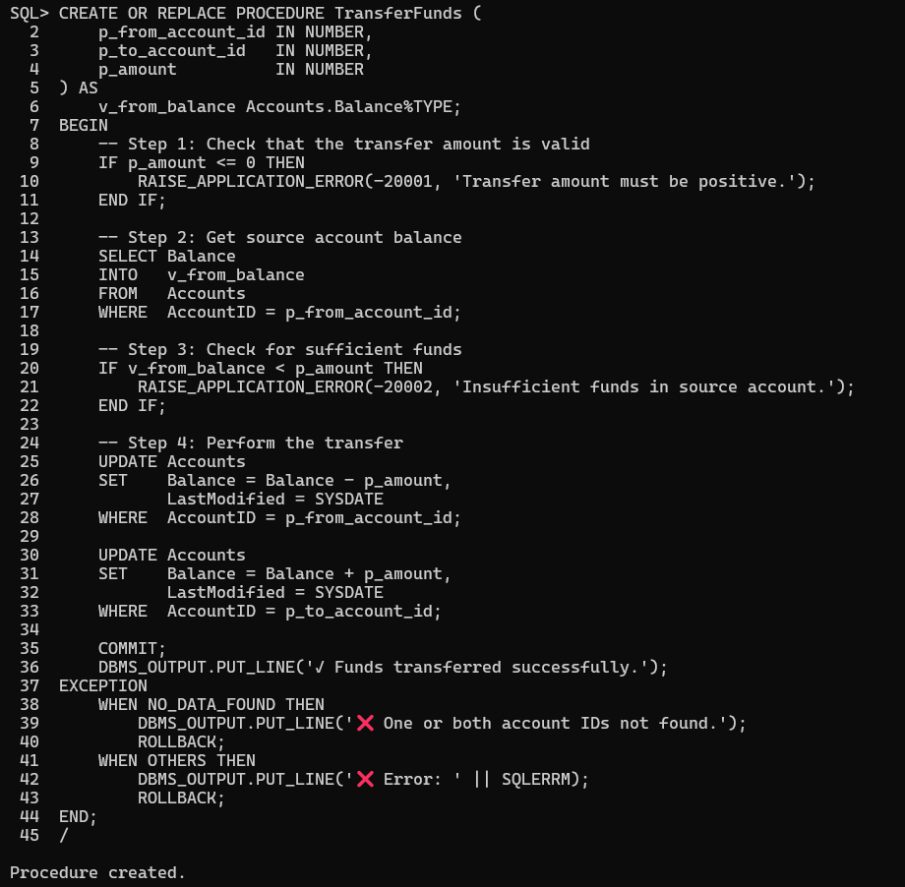

OUTPUT:

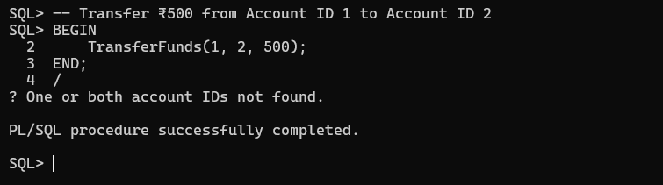

ADDITIONAL HANDSON

**Exercise 2: Error Handling**

**Scenario 1**

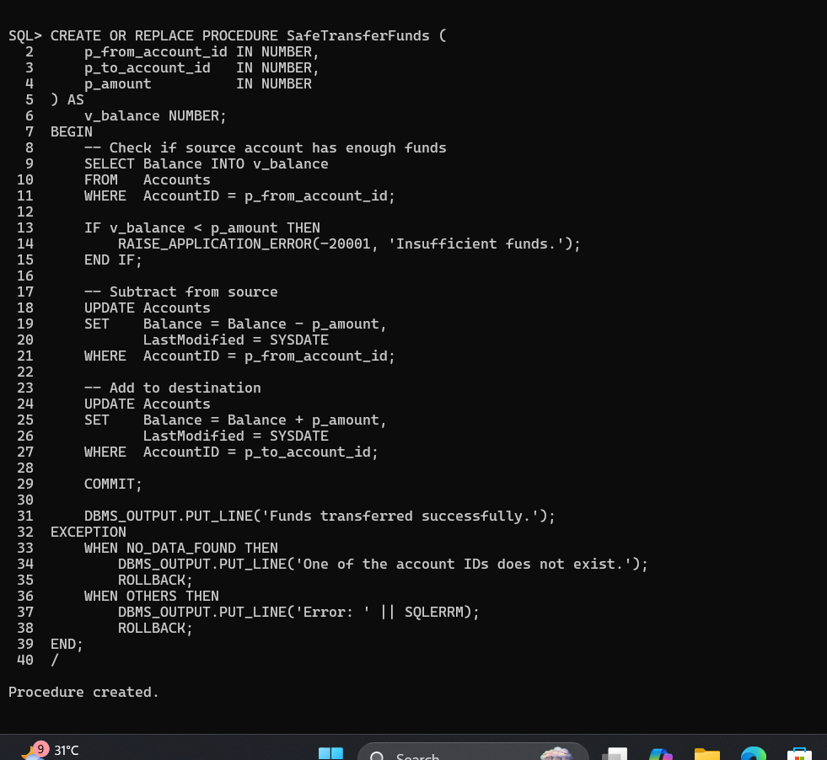

**Scenario 2:**

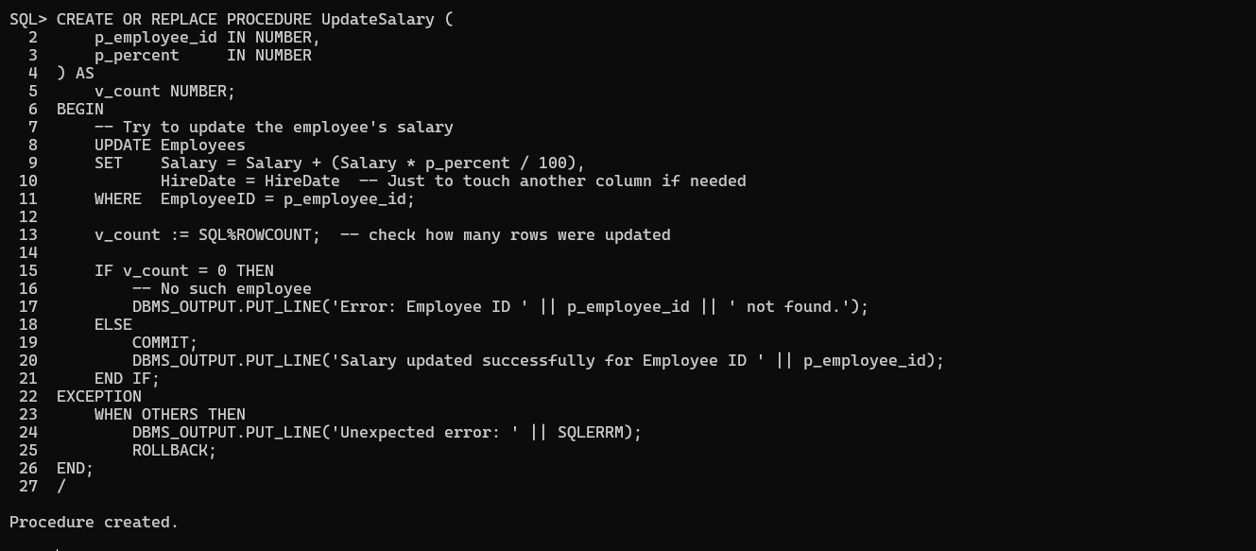

**Scenario 3:**

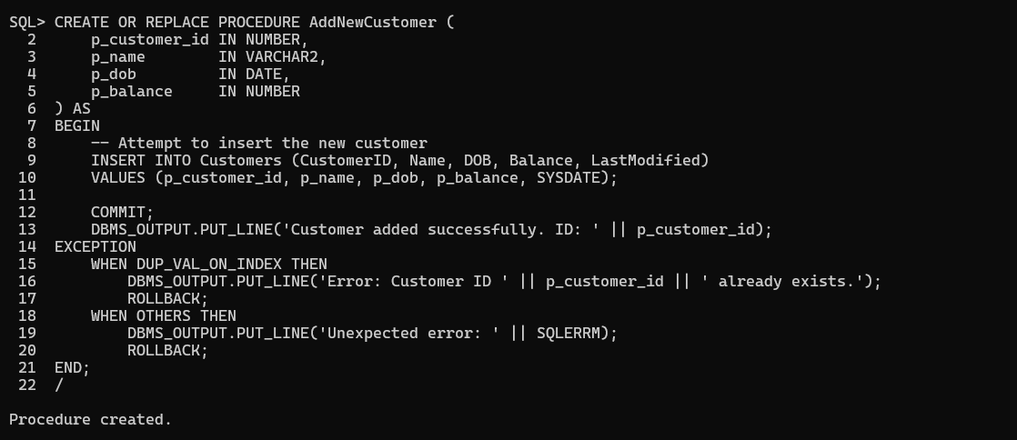

**Exercise 4: Functions**

**Scenario 1**

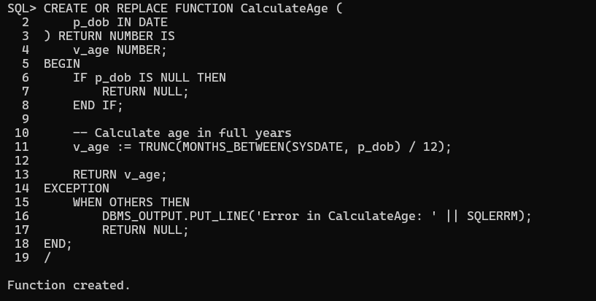

Output:

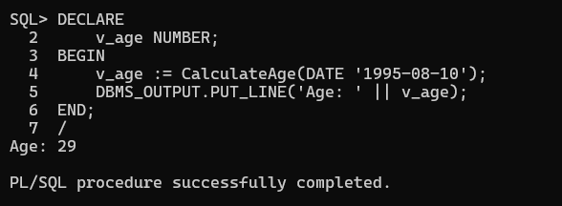

**Scenario 2**

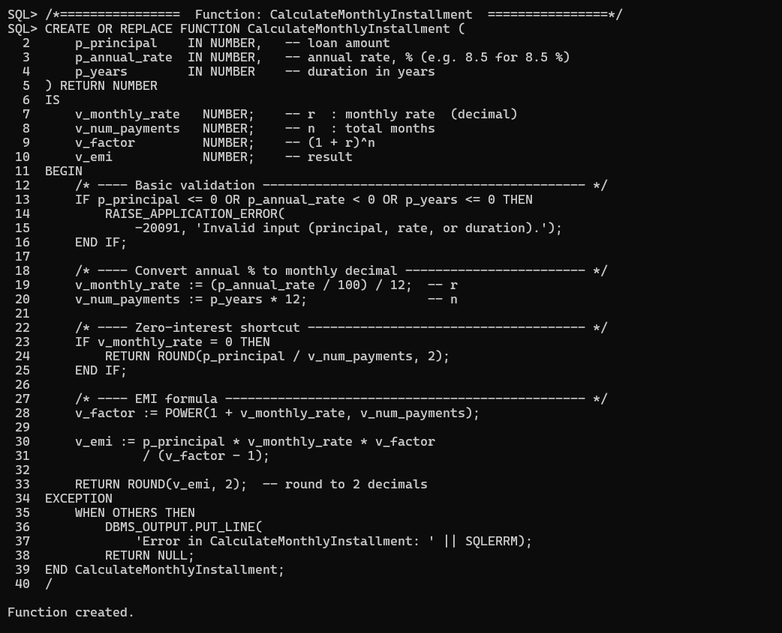

Output:

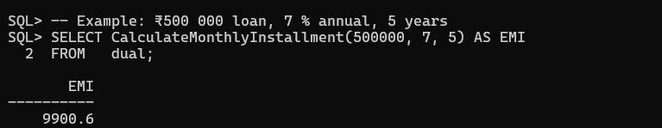

**Scenario 3**

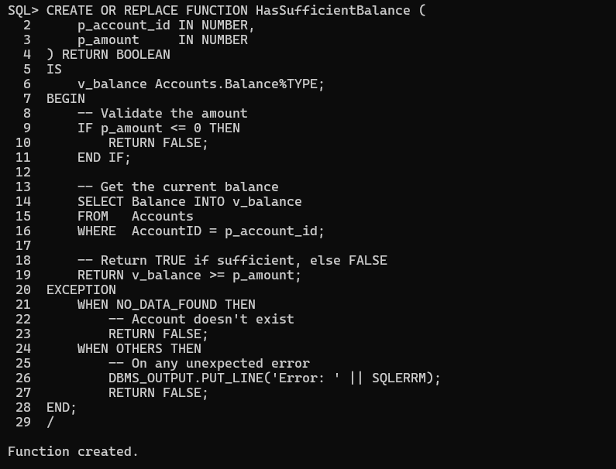

OUTPUT:

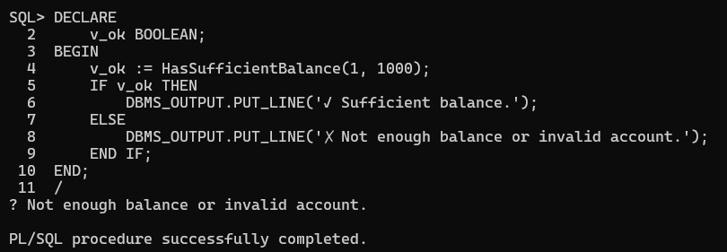

**Exercise 5: Triggers**

**Scenario 1**

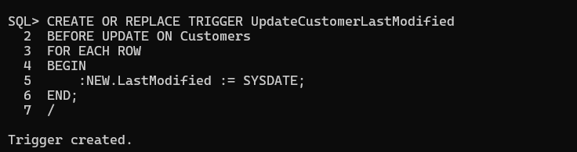2 **Scenario 2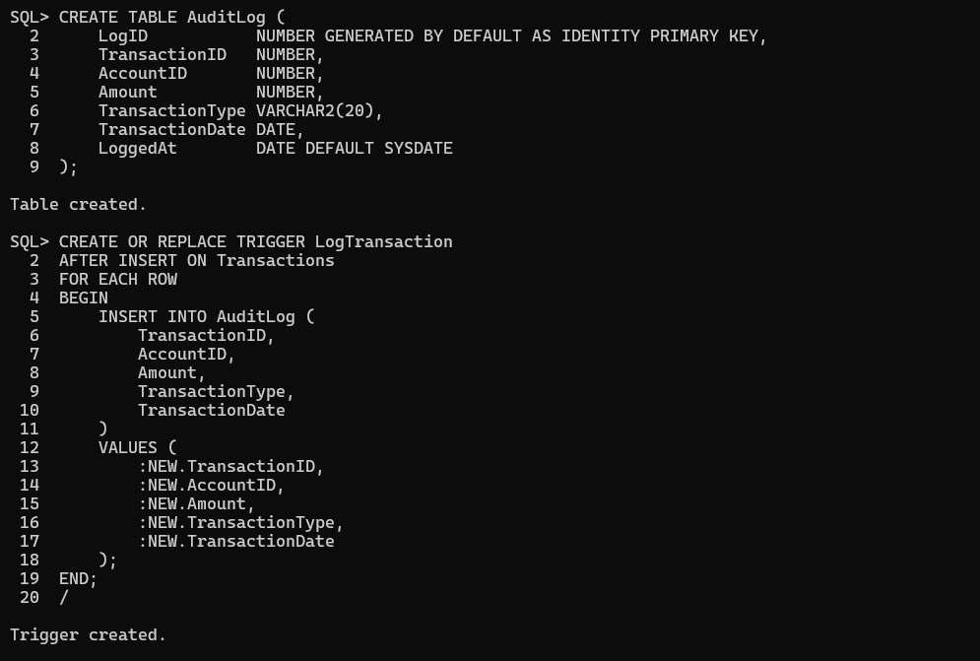Scenario 3**

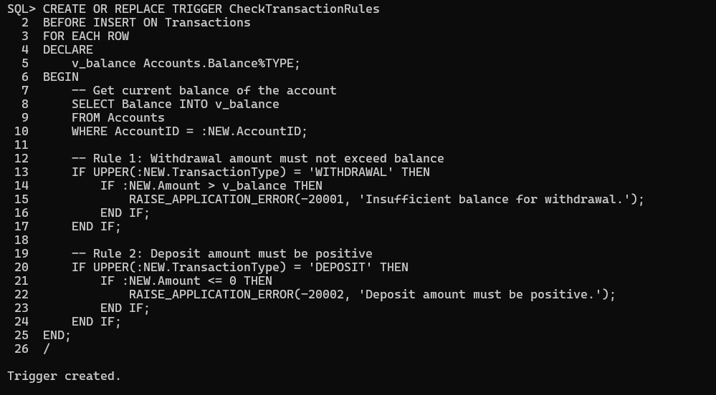

**Exercise 6: Cursors**

**Scenario 1**

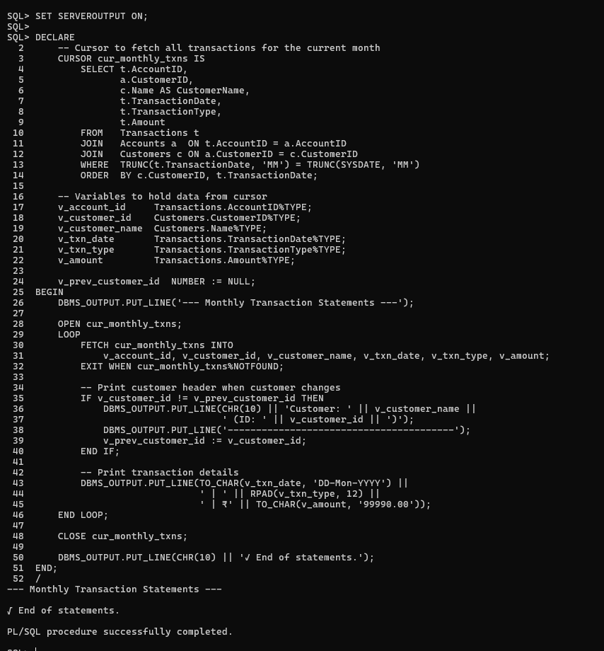

**Scenario 2**

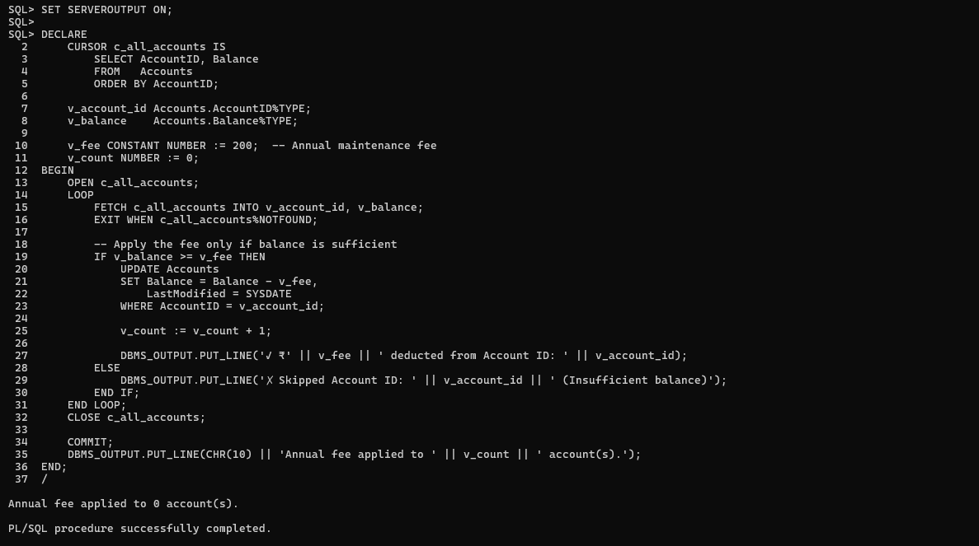

**Scenario 3**

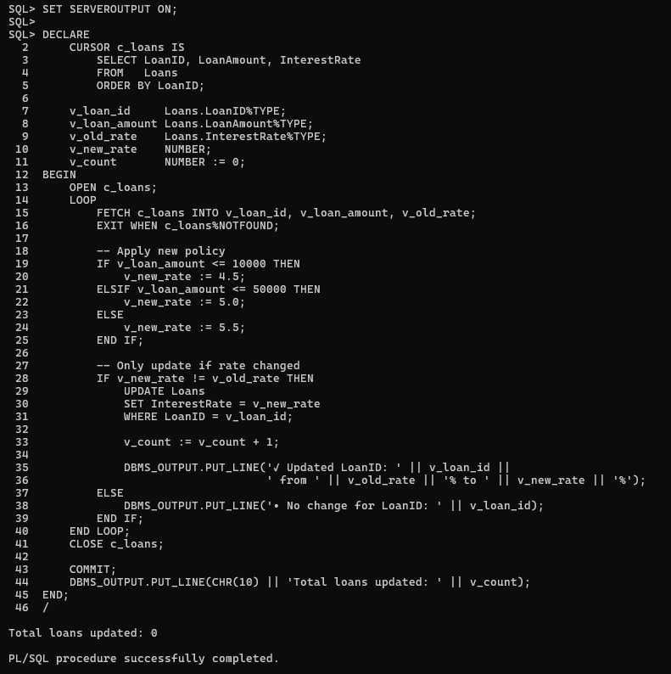

Output:

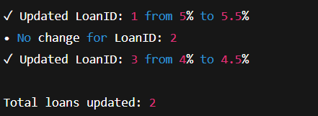

**Exercise 7:Packages**

**Scenario 1**

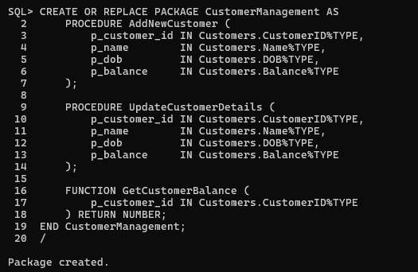

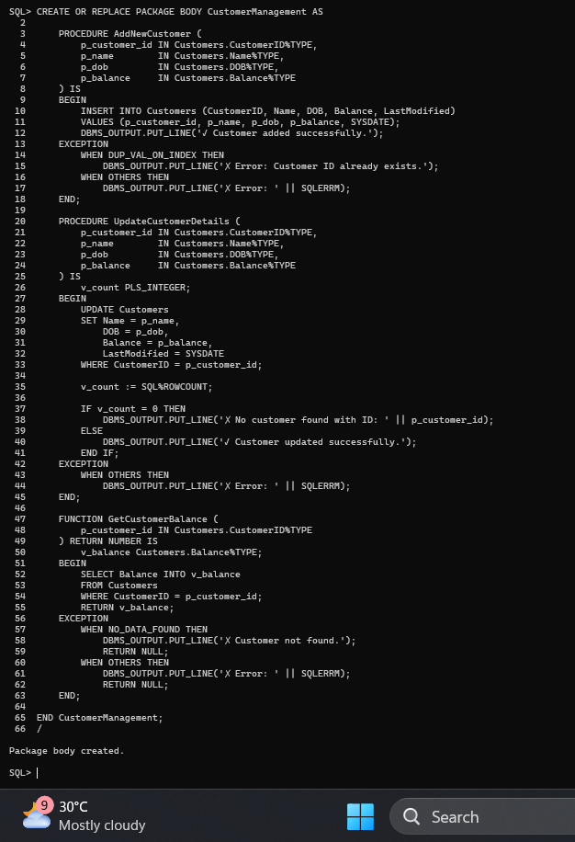

2.

